Supplementary Material 3: Additional graphs

**This supplementary material to the paper, “Effects of stakeholder empowerment on crane population and agricultural production” provides additional graphs, referred to in the paper.**

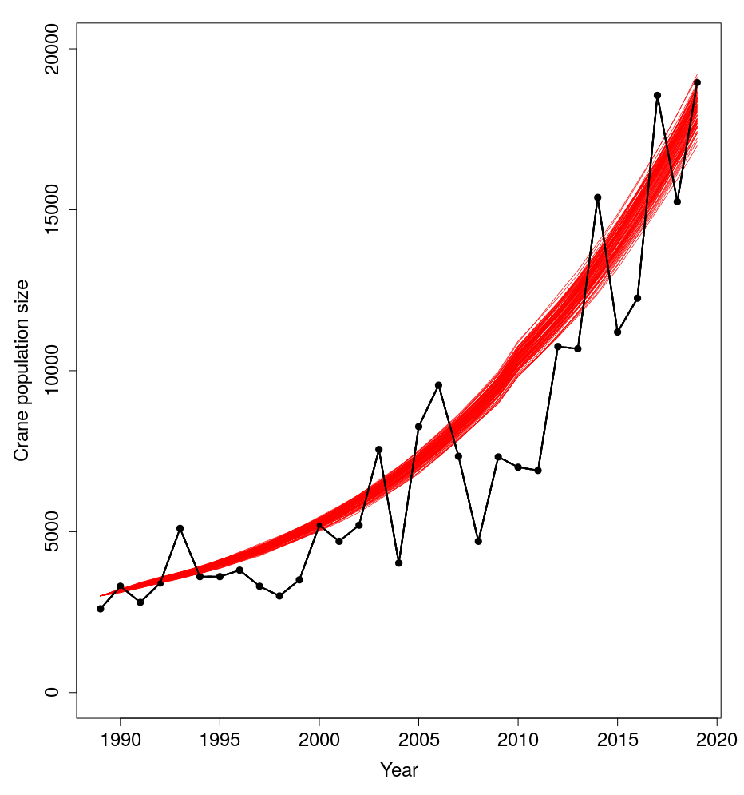

Figure S1. Example simulation replicates to generate simulation initial crane population size. The black line shows empirical data between years 1989-2019 from Lake Hornborga, Sweden. Each red line shows a unique replicate, starting at 3000 individuals in 1989 and following a trajectory that approximates the empirical exponential growth and crane values as observed during 1989-2019.

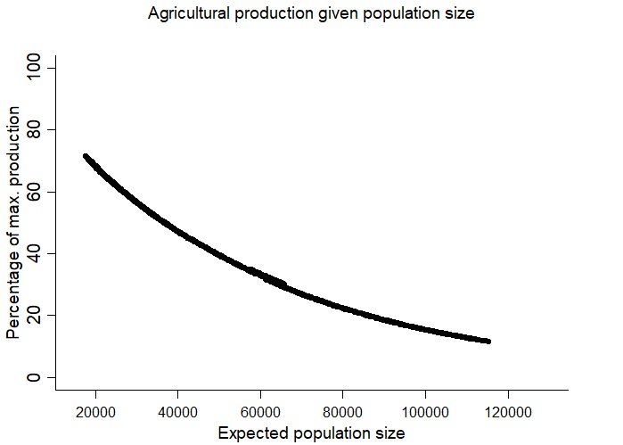

Figure S2. Effect of population size on agricultural production (percentage production of maximum expected production) at staging sites of common cranes for all management scenarios combined year 2020-2049. The percentage agricultural production of maximum production is produced from 160 model simulations (40 simulations per scenario).

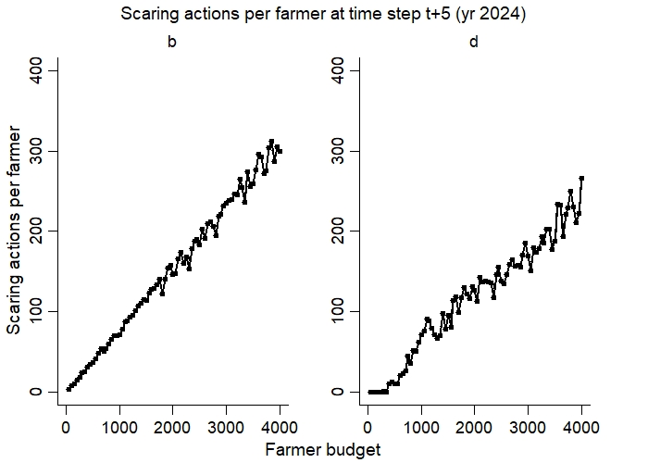

Figure S3. Effect of farmer budgets on number of mean number of scaring actions per stakeholder at staging sites of common cranes for management scenario at year 2024, b.) culling and scaring without a realized management target and d.)  scaring and culling, with a maximum management target of 15,000 individuals. No scaring actions was conducted in scenario a and c. The mean number of culled individuals per farmer are based on 50 farmers and are produced from 40 model simulations per scenario.

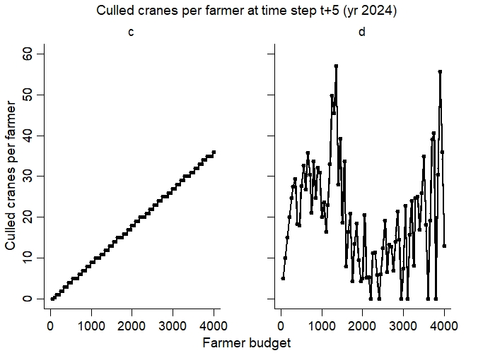

Figure S4. Effects of farmer budgets on mean number of culled individuals per farmer at staging sites of common cranes for management scenario in year 2024, c.) only culling, without a realized management target and d.)  scaring and culling, with a maximum management target of 15,000 individuals. No culling was conducted year 2024 in scenario a and b. The mean number of culled individuals per farmer are based on the simulation output data given 50 farmers and 40 model simulations per scenario.

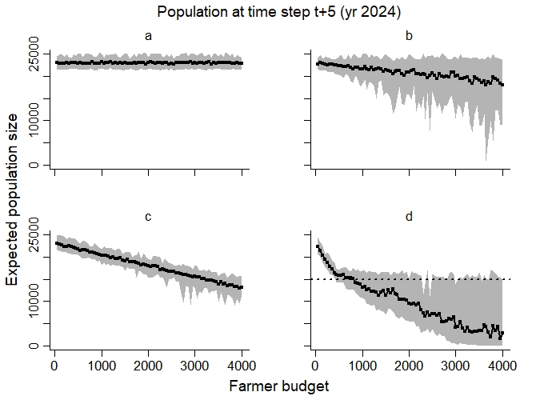

Figure S5. Effect of farmer budgets, including variation (±50) in budget between farmers, on expected population size of common cranes at year 2024 in four different management scenarios; a.) no management, b.) scaring and culling, with a maximum management target of 100,000 individuals, c.) only culling, with a maximum management target of 100,000 cranes, d.)  scaring and culling, with a maximum management target of 15,000 cranes (dotted black line). The mean (black line), minimum and maximum (grey shaded areas) expected population sizes are based on the simulation output data at year 2024, given 50 stakeholders and are produced from 40 model simulations.